Training
Structured Analysis Family Evaluation is Consortium for Children’s standardized home study methodology that has revolutionized the way both public and private child welfare agencies study and evaluate prospective adoptive, kin and foster families.

SAFE assists home study practitioners in performing a thorough, structured and uniform evaluation of families who have applied to foster or adopt.

TWO-DAY COURSE INCLUDES:
SAFE Desk Guide & Workbook  Access to SAFE Forms and Templates  Continued Technical Support  Continued Clinical Support | 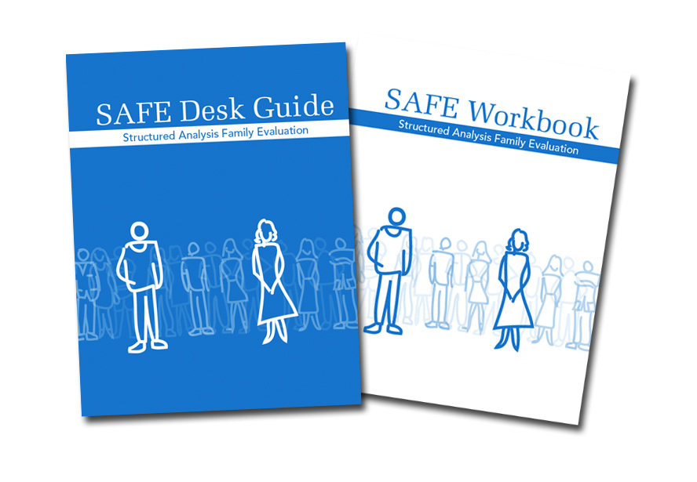

When | February 11-12, 2020
Where | Northside Church  11125 Houze Rd  Roswell, GA 30076
Time | 9:00am - 4:00pm
Cost | $310.00 per person

SAFE provides a structured methodology as well as state of the art tools for social workers to describe, evaluate and strengthen families in a uniform, comprehensive and sensitive fashion.

Register early to ensure your seat.
Pre-Registration is required.

Register online at this link.

