Web Portal RBWO Pre-Bill Instructions
- Log into the smileonline.us website.

- After logging in, click on Where’s My Check Vendor payments.
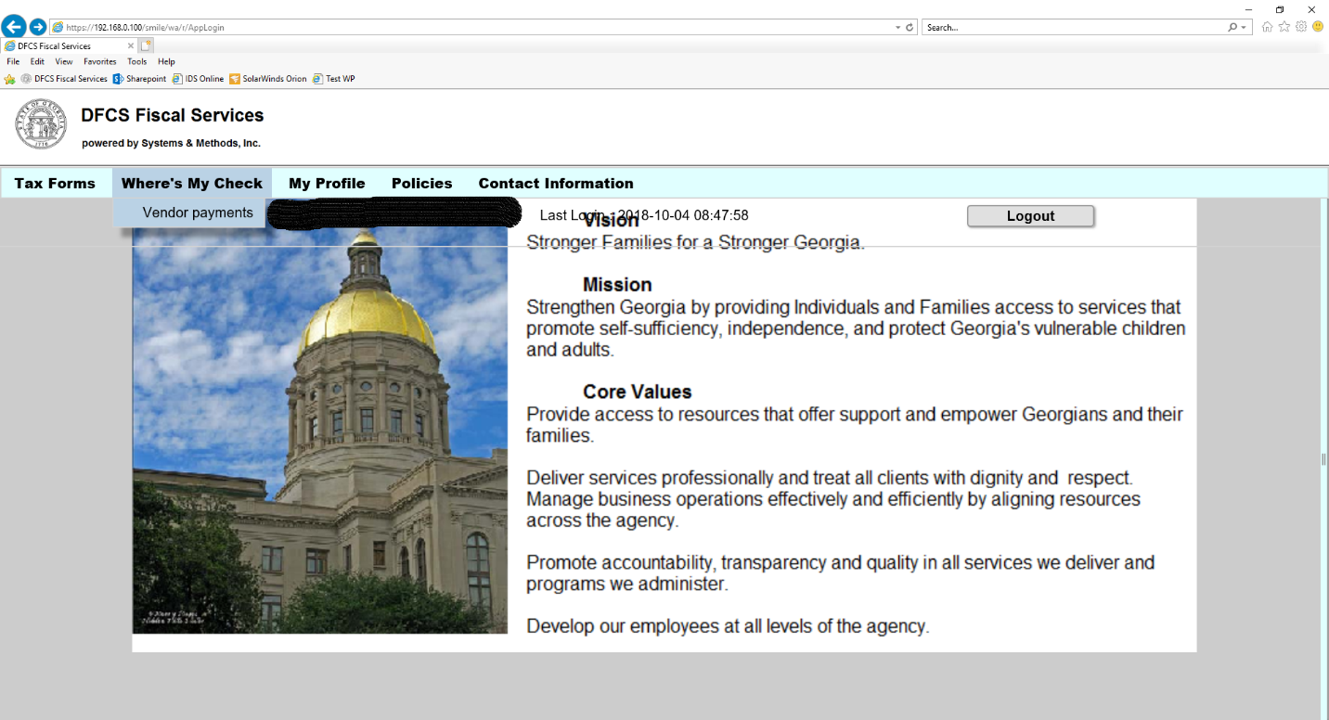
- Click the drop down and select Print PreBill.
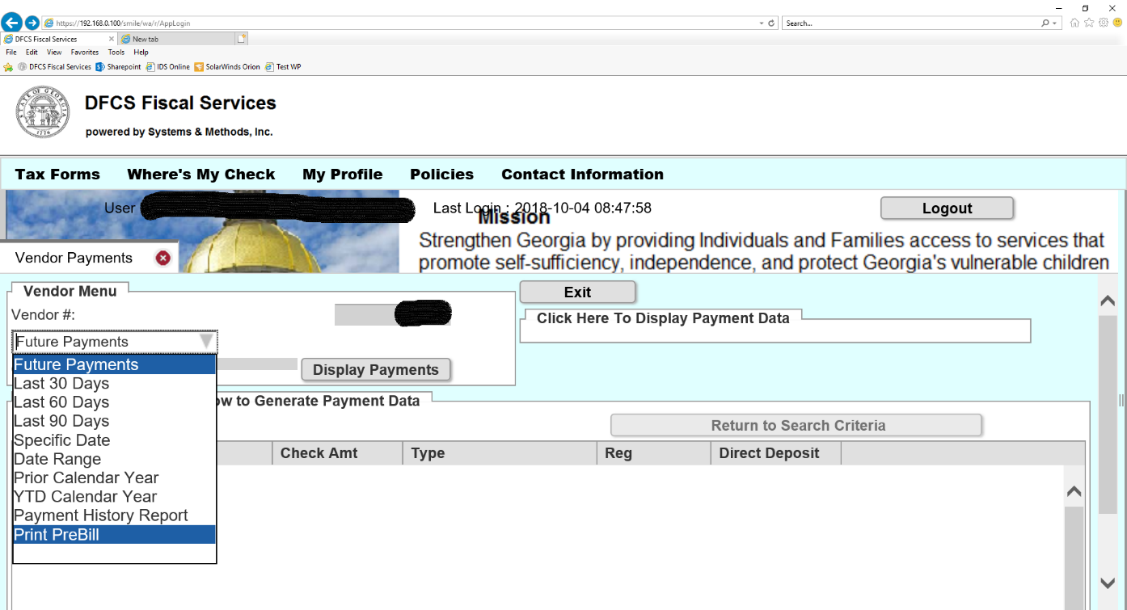

- Enter the Service Month you wish to search for. The Service Month indicates the Year (18) and Month (10) of the services. In this example, 1810 indicates the year 2018 and the month of October. This does not indicate the date of payment for these services.

NOTE: PreBills are available on the 1st of the month for the prior service month. For example, PreBills for October 2018 (1810) will be available November 1st.

After you have entered the service month you wish to search for, click Display Payments. The document will populate and open in a new tab.
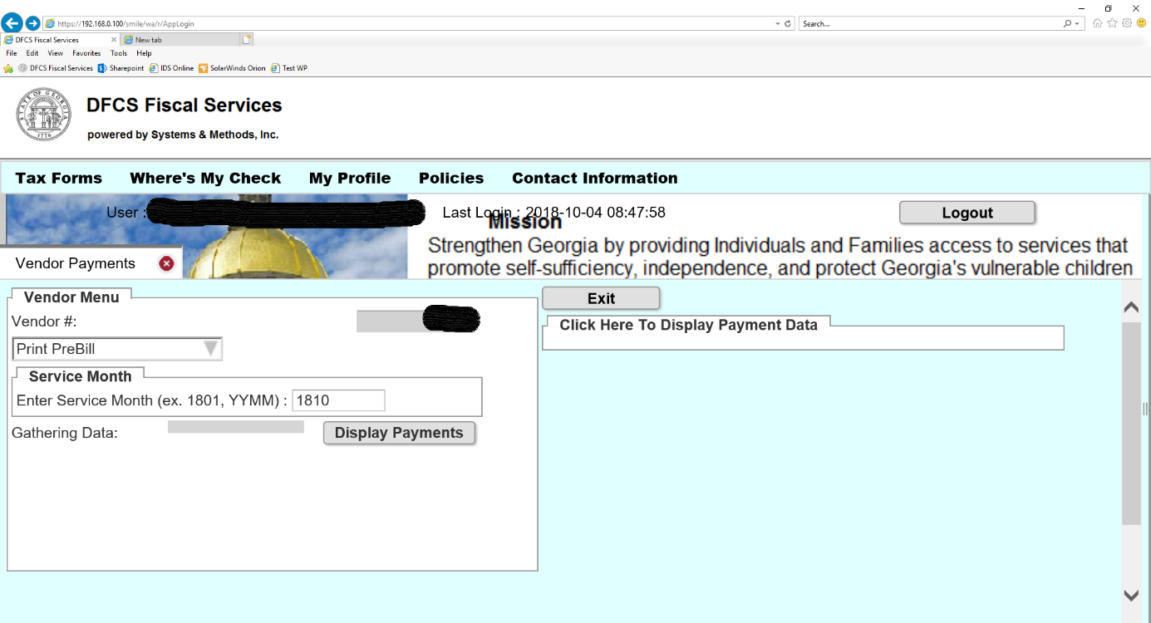
Choose the printer icon (or Ctrl + P) to select your printing options:

- If you enter a service month that isn’t available, you will receive an alert. For example, if the current month is October 2018, you enter October 2018 (1810), and click Display Payments, you will receive an alert that reads, “PreBill for 1810 will not be available until 11/01/2018. Please try later.” You will need to wait until November 1st to view your PreBill for October.

