Supervisors Training
The SAFE Supervisors Training is targeted at Front Line Supervisors who are responsible for the on-going Supervision of Home Studies. The one-day training provides guidance as to how to Supervise SAFE in the most effective manner. The training provides a road map for the Supervision of SAFE as well as tips, supports and suggestions to make the process easier.

Pre-requisite: All Attendees MUST have completed the SAFE 2-day training.

BRING TO CLASS:

The SAFE Desk Guide | 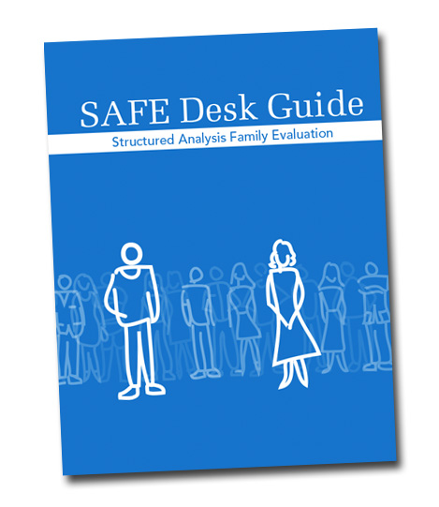

If you no longer have your Desk Guide one may be purchased prior to the training. The cost is $30.00 plus a copy of your SAFE Certification. Please contact becca@consortforkids.org to arrange for a Desk Guide to be provided you at the training.

When | May 1, 2020
Where | Families First  80 Joseph E. Lowery Blvd  Conference Room A/B  Atlanta, GA 30314
Time | 9:00am - 1:00pm
Cost | $150.00 per person.

Pre-Registration is required.

You may register online using this link.

